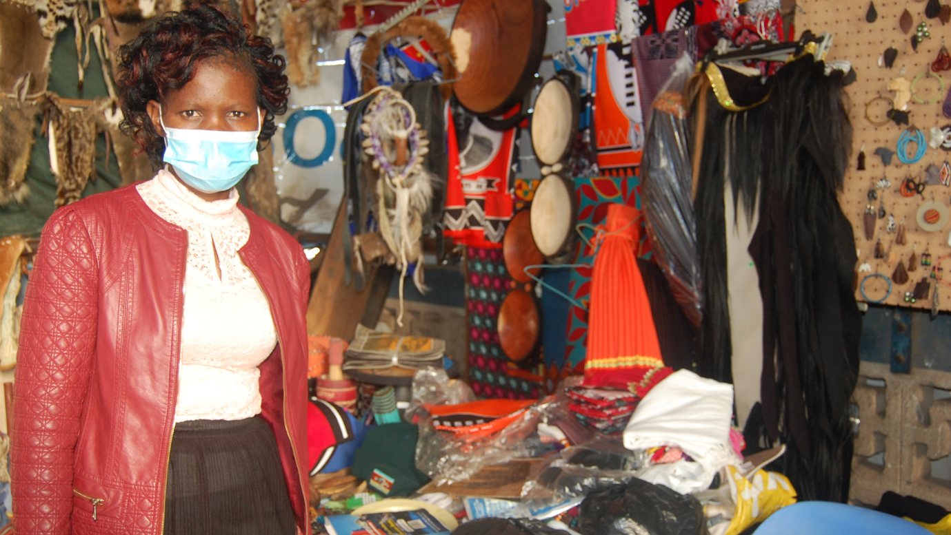
APPLICATION FORM

USAID W-GDP Eswatini Women’s Employment for Economic Recovery Project (WEER)
DFS Innovation Prize

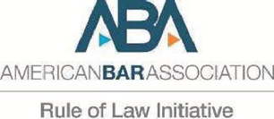

ANNEX 1: SUBMISSION LETTER

Date: _______________

To: USAID W-GDP WEER INNOVATION PRIZE RFA

Dear Madam, Sir

With this letter I, [Name and Surname], in my capacity as legal representative of [Company Name of the Lead Applicant], legally registered at [Address of the Company Registration of the Lead Applicant ] am writing to submit our application for the USAID W-GDP WEER Innovation Prize Request for Applications.

In so doing, I hereby declare as follows:
- All the information and statements made in this application are true and we accept that any misrepresentation contained in it may lead to our disqualification.
- We have no outstanding bankruptcy or pending litigation or any legal action that could impair our operation as a going concern;
- We are currently operating legally in Eswatini and conform to all set rules and regulations governing our work.
We have fulfilled all the obligations relating to the payment of contributions or obligations relating to the payment of taxes in accordance with legal provisions in force in the country of incorporation; we meet the eligibility criteria outlined in the main RFA document and have the documents available to confirm our eligibility.
Additionally, we confirm that if our submission were to be selected, we will:
- Work closely with USAID W-GDP WEER staff to finalize a detailed program work plan, budget, and performance-based milestones for our concept. The award agreement for the project will only be signed after this workplan and budget is developed.
- Be prepared to share relevant supporting documents related to the legal registration and mandate of our company, including among others certificate of registration, certificate of compliance with the tax authorities and any other documentary evidence that might be requested by USAID W-GDP WEER.
- Permit USAID W-GDP WEER Staff to make an in-person site visit to our main and field offices as requested before the award agreement is signed.

Should we be selected as a partner, we commit to endeavour towards successful outcomes of the project upholding the integrity of the proposed idea and desired impact, and at a minimum commit the following:
- Allocating the amount of staff time to implementation, oversight, and supervision of the project as laid out in our budget.
- Allocating the required operational costs associated with the implementation of the project
- Participation in regular progress meetings with the Innovation Prize representatives.
Finally, we fully understand and recognize that USAID W-GDP WEER is not bound to accept this application, that we shall bear all costs associated with its preparation and submission, and that USAID W-GDP WEER will in no case be responsible or liable for those costs, regardless of the conduct or outcome of the evaluation.

Checklist of documents submitted with this letter:

- Annex I – Declaration letter
- Annex II – Application form
- Annex III – Workplan
- Annex IV – Budget
- Copy of the applicants Certificate of incorporation
- Copy of the applicant’s Trading License
- Copy of the applicants Financial Services Regulatory Authority (FSRA) certificate
- CVs of key employees / team involved in the project

Yours sincerely,
Authorized Signature [In full and initials]:
Name and Title of Signatory:
Name of Company:
Contact Details:
[Please mark this letter with your corporate stamp, if available]

Annex II: Application Form
Instructions for applicants:
- Applicants should fill in the following application form in minimum 11 point font (any style font is ok)
- Applicants should answer every question in the application form
- It is recommended to read the entire application form before beginning to fill it out.
SECTION 1: GENERAL APPLICANT INFORMATION
Name of your Organization (legal name)
Provide name and surname of the legal representative
Email of the legal representative
Phone number of the legal representative
Year of Incorporation of your Organization
Company Registration number
FSRA number (if applicable)
Postal Address
Physical Address
Type of Entity / Legal Status
Website URL
Social Media URL (Facebook)
LinkedIn
YouTube
Instagram
Other
- Description of Organization: Tell us more about your organization. (max 2 pages)
What type of organization are you and when were you founded?
What is your mission, vision and values?
What are your key services and products?
Which regions of Eswatini do you serve?

SECTION 2: EXECUTIVE SUMMARY (max Half-page)
Briefly describe the overall goals, expected outcomes and technical approach of your project.

SECTION 3: PROPOSED APPROACH AND IMPLEMENTATION PLAN (total Section 3 max 10 pages)
- Problem: What specific problem or gap, related to access to finance for women entrepreneurs, is your Innovation Prize project trying to address? This problem can be something described in the Financial Ecosystem Gap Analysis and/or something your organization has noted through other sources.
- Goals, Objectives and Expected Results: What are the overall goals, objectives and expected outcomes of your project?
- Project Description: Please provide a detailed description of the activities and technical approach that you will undertake to address the problems described above, and improve access to finance for business for at least 5,000 women entrepreneurs.
- Impact on Women’s Businesses: How will the proposed innovation improve women’s ability to start and grow successful businesses--– especially the earning potential and size of the businesses?
- Performance Indicators: Provide figures on the number of financial products developed, number of women by region that will be reached by your innovation during the project period.
Number of financial products developed or scaled up:
Number of women with increased access to finance as a result of the project:
Number of women who take up new financial products as a result of your project during the project period:
Applicants may include additional indicators here if they wish:
Additional indicator:
Additional indicator:
Additional indicator:
Additional indicator:
Additional indicator:
Additional indicator:

- Additionality: Is the innovation you are proposing, a new financial product or activity that has never been implemented before, or is it a scale-up of an existing product? If it is a scale-up, explain how project funds will be used to add value to what you are already doing (for example will the funds be used to scale up the product to additional geographic areas and how, will the funds be used to build awareness of existing underutilized products and how, etc.)
- Financial Education Component: Every Innovation Prize project must have a financial education component that at a minimum educates users about the terms and conditions of the product. Describe the activities you will undertake to incorporate financial education and product awareness into your proposed project. Additionally, describe how you will incorporate consumer protection into your proposed innovation.
- Geographic Reach: What is the geographic scope of the financial inclusion product/innovation? Describe the current offices, structures and other resources you have available to implement the project in the specified geographic areas.
- Post-Project Sustainability and Scale-up: How sustainable will the proposed innovation be after the 12-month project period? Will the proposed financial product/innovation continue to be available to or benefit a large number of women entrepreneurs in Eswatini after the project period? Will it scale up to new users? Describe the sustainability mechanisms for the proposed innovation.
- Management Structure: Briefly describe the project management structure and roles of key team members involved in the project (for example the Project Manager, IT, Project Officers, Finance, etc.)
- Roles and Responsibilities Partners: Do you have any partners that you are/would like to work closely with in this project? e.g. SACCOS, MFIs, FSPs, MNOs, Fintech companies, NGO, government, etc.
Partner | Role and responsibilities in the implementation of the project | Is there a partnership formalized? What type of agreement is in place?

- Risks: Provide an overview of what the key risks to success of your project might be, and how you will mitigate (prevent or reduce the effects of) these risks.
Describe the potential risks for the implementation of this project that may impact achievement and timely completion of expected results as well as their quality. Describe measures that will be put in place to mitigate these risks.
Description of risk | Likelihood | Impact | Mitigation measure

SECTION 4: ORGANIZATIONAL CAPACITY
- Describe your organization and partner organizations’ technology, management and infrastructure resources related to implementing the proposed innovation. (Max 1 page)
- Describe your organization and partner organizations’ experience implementing similar innovations. This can include your organization’s experience implementing women’s financial inclusion programming, successfully developing and rolling out digital financial services products, or similar. Include the years of implementation, number of people reached and other descriptions of the work. (Max 3 pages)

SECTION 5: WORKPLAN AND BUDGET

- Workplan: Detail out the project’s activities, sequencing, and timeframe in Annex III-Workplan.
Please use the template provided in Annex III – Workplan..
- Budget: Provide your budget request to USAID WEER in Annex IV -- Budget
Please use the template provided in Annex IV – Budget

- All Innovation Prize applicants must provide at least 1 to 1 in-kind or cash matching funds to the Prize grant provided by USAID WEER. This means if your organization’s total grant request to USAID WEER is $30,000 for an Innovation Prize project, then your organization must also provide at least $30,000 in matching funds toward the project. Please briefly describe what your organization will provide as cost share (for example loaning funds, management staff time, technology, etc.)
Please also include an estimate of Cost Share costs in Annex IV-Budget.

Annex III--Work Plan (no page limit)
Instructions for Applicants:
You may add additional rows if you need more space
Description | Performance Target (example: 50 people trained, 1 platform built, 1 training manual completed, etc) | 1 | 2 | 3 | 4 | 5 | 6 | 7 | 8 | 9 | 10 | 11 | 12
Main Activity | XX
Sub activity
Sub activity
Sub activity
Main Activity
Sub activity
Sub activity
Main Activity
Sub activity
Sub activity
Main Activity
Sub activity
Sub activity
Main Activity
Sub activity
Sub activity

SECTION 4: REMINDER ON ATTACHMENTS

The full application is expected to have the following Annexes and attachments:

- Annex I – Declaration letter
- Annex II – Application form
- Annex III – Workplan
- Annex IV - Budget
- Certified copy of the applicants Certificate of incorporation
- Certified copy of the applicant’s Trading License
- Certified copy of the applicants FSRA certificate
- CVs of the employees / team involved in the project in PDF form

Thanks for completing this Application.
We have one last question.
How did you find out about this RFA | ☐ | Facebook
 | ☐ | LinkedIn
 | ☐ | Twitter
 | ☐ | Newspaper/media
 | ☐ | Colleagues/ Friends
 | ☐ | Other (please specify)
 |  | Specify

